Community Health Needs Assessment
Chase County Community Hospital (CCCH) was established back in the mid-twenties, due to the vision and courage of two young nurses, Chase County was fortunate in acquiring its first hospital. In 1925, Elva and Evea Yaw bought a house in Imperial and called their venture a 10 bed “Home Hospital”. Dr. George Hoffmeister then moved his emergency services to a room in their “Home Hospital”. It was not long after they realized they needed more room and an operating room, therefore adding on another room. In 1929, due to some personal changes by the existing staff the “home hospital” was rented out as a residence and the equipment was sold.
It was not long after when many local businessmen of Imperial realized a great need for a hospital here and decided to canvass the surrounding territory to raise sufficient funds to start a new hospital. The Imperial Community Hospital opened in the spring of 1931 and added on more rooms in 1958. The next groundbreaking ceremony took place in 1976 and the ‘New’ Chase County Hospital commenced in the summer of 1977. In 1992, an addition for outpatient and physical therapy services was constructed, and 25 years later, groundbreaking occurred again to add a hospital affiliated clinic. Our mission is to enhance the quality of life in our community by providing accessible, affordable, and compassionate healing for those in need while emphasizing prevention and health promotion as effective ways to reduce health care costs. This is without regard to race, gender, sexual orientation, economic status, or religion.
Today Chase County Community Hospital is a 22 bed Critical Access Hospital with acute care services, swing bed services, Level VI trauma designation, 24-hour emergency services and a wide range of diagnostic and therapeutic services provided to inpatients and outpatients. CCCH employs more than eighty employees in the various departments. The affiliated Chase County Clinics employ two physicians, one physician assistant and one nurse practitioner. There are also many specialists offering their services on a monthly basis.
CCCH is governed by a five-member board appointed by the county commissioners to a six year term.

Community Served
Geographic Area
Chase County Community Hospital is the only Critical Access Hospital in Chase County, serving a population of nearly 4,000 residents. The townships included in Chase County include: Imperial, Wauneta, Champion, Lamar and Enders and the surrounding rural residents. Overlapping counties also served are Dundy and Hays counties respectively.
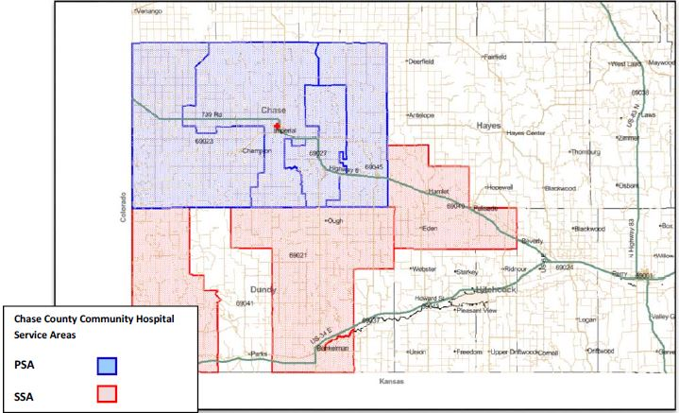
Inpatient Percentages
Svc Area | ZIP | County | City | Volume | % of Total
PSA | 69033 | Chase | IMPERIAL | 65 | 47.8%
 | 69045 | Chase | WAUNETA | 28 | 20.6%
 | 69023 | Chase | CHAMPION | 11 | 8.1%
 | 69027 | Chase | ENDERS | 4 | 2.9%
PSA Total |  |  |  | 108 | 79.4%
SSA | 69040 | Hayes | PALASADE | 12 | 8.8%
 | 69021 | Dundy | BENKELMAN | 7 | 5.1%
 | 69030 | Dundy | HAIGLER | 5 | 3.7%
SSA Total |  |  |  | 24 | 17.6%
PSA/SSA Total |  |  |  | 132 | 97.1%
Other Total |  |  |  | 4 | 2.9%
Grand Total |  |  |  | 136 | 100.0%

Target Populations
The following table outlines the target populations, according to the Census Bureau, served in Chase County, Nebraska. Chase County Community Hospital and Clinic does not focus on any specific population group but strives to provide care to those who seek it in our area.

People | Chase County, Nebraska
Population
Population estimates, July 1, 2015, (V2015) | 3956
Population, percent change - April 1, 2010 (estimates base) to July 1, 2015, (V2015) | -0.3
Population, Census, April 1, 2010 | 3966
Age and Sex
Persons under 5 years, percent, July 1, 2014, (V2014) | 5.7
Persons under 5 years, percent, April 1, 2010 | 7.1
Persons under 18 years, percent, July 1, 2014, (V2014) | 24.1
Persons under 18 years, percent, April 1, 2010 | 23.8
Persons 65 years and over, percent, July 1, 2014, (V2014) | 20.7
Persons 65 years and over, percent, April 1, 2010 | 20.4
Female persons, percent, July 1, 2014, (V2014) | 51.2
Female persons, percent, April 1, 2010 | 50.5
Race and Hispanic Origin
White alone, percent, July 1, 2014, (V2014) (a) | 98.6
White alone, percent, April 1, 2010 (a) | 91.9
Black or African American alone, percent, July 1, 2014, (V2014) (a) | 0.2
Black or African American alone, percent, April 1, 2010 (a) | 0.1
American Indian and Alaska Native alone, percent, July 1, 2014, (V2014) (a) | 0.4
American Indian and Alaska Native alone, percent, April 1, 2010 (a) | 0.1
Asian alone, percent, July 1, 2014, (V2014) (a) | 0.1
Asian alone, percent, April 1, 2010 (a) | 0.1
Native Hawaiian and Other Pacific Islander alone, percent, July 1, 2014, (V2014) (a) | 0.0
Native Hawaiian and Other Pacific Islander alone, percent, April 1, 2010 (a) | 0.0
Two or More Races, percent, July 1, 2014, (V2014) | 0.8
Two or More Races, percent, April 1, 2010 | 1.2
Hispanic or Latino, percent, July 1, 2014, (V2014) (b) | 12.6
Hispanic or Latino, percent, April 1, 2010 (b) | 11.1
White alone, not Hispanic or Latino, percent, July 1, 2014, (V2014) | 86.3
White alone, not Hispanic or Latino, percent, April 1, 2010 | 88.0
Population Characteristics
Veterans, 2010-2014 | 273
Foreign born persons, percent, 2010-2014 | 7.4

This geographic level of poverty and health estimates are not comparable to other geographic levels of these estimates.
Some estimates presented here come from sample data, and thus have sampling errors that may render some apparent differences between geographies statistically indistinguishable.
The vintage year (e.g., V2015) refers to the final year of the series (2010 thru 2015). Different vintage years of estimates are not comparable.
(1) Includes data not distributed by county.
(a) Includes persons reporting only one race
(b) Hispanics may be of any race, so also are included in applicable race categories
QuickFacts data are derived from: Population Estimates, American Community Survey, Census of Population and Housing, Current Population Survey, Small Area Health Insurance Estimates, Small Area Income and Poverty Estimates, State and County Housing Unit Estimates, County Business Patterns, Nonemployer Statistics, Economic Census, Survey of Business Owners, Building Permits.
Data Source: US Census Bureau, American Community Survey. 2010-14. Source geography: County
Selected characteristics of the County population include:
- The county population is estimated to be 3,956 for 2015
  - Roughly 48.47% being male and 51.53% female.
  - Approximately 861 residents are age 65 or greater. 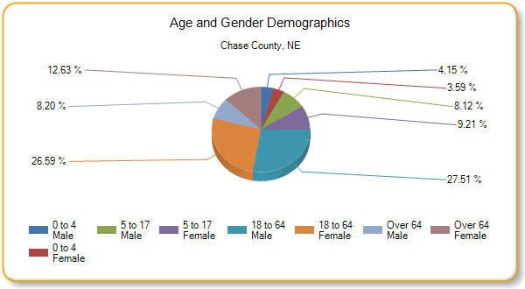
- The ethnicity of the population makeup is around 12.18% Hispanic and 87.82% non-Hispanic.
- It is estimated that there were 189 households, or 11.13%, living in poverty within the report area.
  - According to the American Community Survey 5 year estimates, an average of 12.07 percent of all persons lived in a state of poverty during the 2010 - 2014 period.
  - The poverty rate for all persons living in the report area is less than the national average of 15.59 percent.
- According to the U.S. Census, the poverty rate for the area decreased by -3.5%, compared to a national increase of 6 percent. The poverty rate for children ages 0-17 in 2014 was 10.8%.
- County Health Rankings reports that:
  - 72% of the population has some college education.
  - 24% of the children in Chase County are eligible for free lunch
  - Chase County ranks 45th in the state of Nebraska out of 78 counties ranked according to overall health outcomes. Health outcomes are based on length of life and quality of life.
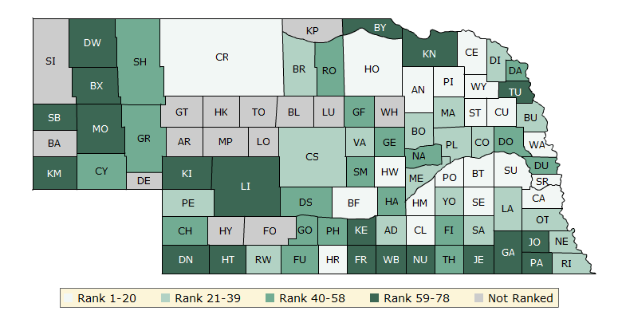
            - Length of life is based on premature death. Premature Death is the years of potential life lost before age 75. The intent of this measure is to focus on deaths that potentially could have been prevented.
            - “Self-reported health status is a general measure of health-related quality of life (HRQoL) in a population. This measure is based on survey responses to the question: “In general, would you say that your health is excellent, very good, good, fair, or poor?” The value reported in the County Health Rankings is the percentage of adult respondents who rate their health “fair” or “poor.” The Behavioral Risk Factor Surveillance System (BRFSS) is a state-based random digit dial (RDD) telephone survey that is conducted annually in all states, the District of Columbia, and U.S. territories.” http://www.countyhealthrankings.org/measure/poor-or-fair-health

  - Chase County ranks 10th out of 78 counties rated in Nebraska for overall health factors. According to County Health Rankings, “The overall rankings in health factors represent what influences the health of a county. They are an estimate of the future health of counties as compared to other counties within a state. The ranks are based on four types of measures: health behaviors, clinical care, social and economic, and physical environment factors.”
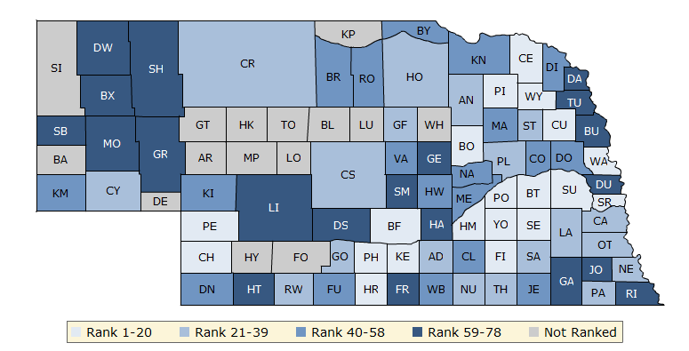

Chase County, NE
“The following Summary Comparison Report provides an “at a glance” summary of how the selected county compares with peer counties on the full set of Primary Indicators. Peer county values for each indicator were ranked and then divided into quartiles.” Explanation of this chart is found at http://wwwn.cdc.gov/CommunityHealth/profile/currentprofile/NE/Chase/
 | Better (most favorable quartile) | Moderate (middle two quartiles) | Worse (least favorable quartile)
Mortality | - Coronary heart disease deaths  - Male life expectancy | - Cancer deaths  - Female life expectancy  - Stroke deaths  - Unintentional injury (including motor vehicle) | - Chronic lower respiratory disease (CLRD) deaths
Morbidity | - Adult overall health status  - Gonorrhea  - Syphilis | - Adult diabetes  - Adult obesity  - Alzheimer's diseases/dementia  - Cancer  - Older adult asthma  - Older adult depression  - Preterm births
Health Care Access and Quality | - Cost barrier to care | - Older adult preventable hospitalizations  - Primary care provider access  - Uninsured
Health Behaviors | - Adult physical inactivity  - Adult smoking | - Adult female routine pap tests  - Teen Births | - Adult binge drinking
Social Factors | - On time high school graduation  - Unemployment | - High housing costs  - Inadequate social support  - Poverty  - Violent crime | - Children in single-parent households
Physical Environment | - Access to parks  - Limited access to healthy food  - Living near highways | - Annual average PM2.5 concentration  - Housing stress
Current Unemployment
Labor force, employment, and unemployment data for each county in the report area is provided in the table below. Overall, the report area experienced an average 2.1% percent unemployment rate in March 2016.
Report Area Labor Force Number Employed Number Unemployed Unemployment Rate  Chase County, NE 2,367 2,317 50 2.1%  Nebraska 1,020,705 987,485 33,220 3.3%  United States 159,988,338 151,733,570 8,254,768 5.2%  Data Source: US Department of Labor, Bureau of Labor Statistics. 2016 - March. Source geography: County | Unemployment Rate  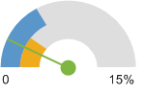  Chase County, NE (2.1%)  Nebraska (3.3%)  United States (5.2%)

Income Levels
Two common measures of income are Median Household Income and Per Capita Income, based on U.S. Census Bureau estimates. Both measures are shown for the report area below. The average Per Capita income for the report area is $30881, compared to a national average of $28,155.
Report Area | Median Household Income | Per Capita Income
Chase County, NE | $48,450 | $30,881
Nebraska | $52,400 | $27,339
United States | $53,482 | $28,555
Data Source: US Census Bureau, American Community Survey. 2010-14. Source geography: County

Medicare and Medicaid Providers
Total institutional Medicare and Medicaid providers, including hospitals, nursing facilities, federally qualified health centers, rural health clinics and community mental health centers for the report area are shown. According to the U.S. Department of Health and Human Services, there were 5 active Medicare and Medicaid institutional service providers in the report area in the third quarter of 2015.
Report Area | Total Institutional Providers | Hospitals | Nursing Facilities | Federally Qualified Health Centers | Rural Health Clinics | Community Mental Health Centers
Chase County, NE | 5 | 1 | 2 | 0 | 2 | 0
Nebraska | 714 | 101 | 216 | 30 | 137 | 0
United States | 71,733 | 7,173 | 15,657 | 6,733 | 4,100 | 225
Data Source: US Department of Health Human Services, Center for Medicare Medicaid Services, Provider of Services File. Sept. 2015. Source geography: County

All Providers of Service, POS Sept. 2015
Report Area

Persons Receiving Medicare
The total number of persons receiving Medicare is shown, broken down by number over 65 and number of disabled persons receiving Medicare for the report area. The U.S. Department of Health and Human Services reported that a total of 914 persons were receiving Medicare benefits in the report area in 2013. A large number of individuals in our society are aware that persons over 65 years of age receive Medicare; however, many of them are unaware that disabled persons also receive Medicare benefits. A total of 82 disabled persons in the report area received Medicare benefits in 2013.
Report Area | Persons Over 65 Receiving Medicare | Disabled Persons Receiving Medicare | Total Persons Receiving Medicare
Chase County, NE | 832 | 82 | 914
Nebraska | 265,962 | 50,249 | 316,221
United States | 43,739,904 | 10,384,773 | 54,124,727
Data Source: Centers for Medicare and Medicaid Services. 2009-13. Source geography: County—get updated data
Bryan Health Outmigration Study prepared by Amy Meyers, Market Analyst and Planning Strategist showed us projected population for those ages 65+ in our specific primary service area (PSA) and secondary service area (SSA) as shown below.
 | PSA | Growth | SSA | Growth
2018 Projection | 4,219 | 3.9% | 2,206 | -3.9%
65+ Population | 931 | 10.2% | 578 | 6.3%
2013 Estimate | 4,060 | -0.1% | 2,295 | -13.8%
65+ Population | 845 | -1.5% | 544 | -6.7%
2000 Census | 4,064 | - | 2,662 | -
65+ Population | 858 | - | 583 | -

Descriptions of Meetings, Focus Groups, Surveys
Process, Strategy, and Community Input

Chase County Community Hospital started the process of aligning facility priorities with community needs on May 20, 2015 by meeting with Deidra Byrne from D Byrne Advisors, Strategic Advisory Services. As a leadership team, along with the executive board, the group met to discuss a strategic plan and potential future initiatives for the hospital and clinic. Then in September of 2015, Southwest Public Health Department, along with area hospital representatives met for a foundational meeting to establish a framework for completing a community health assessment blueprint. To assist in establishing a framework, we were guided through a process called “Forces of Change.” This assessment helped the group identify what changes are relevant in each community relating to healthcare. Meeting with the area hospital representatives was important due to the fact that although each hospital is located in a different county there is often a population overlap for service areas. The intent of the community health needs assessment is to ensure that needs are being met in Southwest Nebraska by describing the health status of the population, identifying areas for improvement in health, determine factors that contribute to health related conditions, and identify resources that can be utilized to address population health issues. The Southwest Public Health Department report and charts are as follows, and up to the next section on Local Community Input:
During the public health department led process the group learned that FORCES OF CHANGE are trends, factors or events, defined as:
- TRENDS are patterns over time, such as migration in and out of a community or a growing disillusionment with government.
- FACTORS are discrete elements, such as a state or community’s large ethnic population, an urban or rural setting, or a jurisdiction’s proximity to a major waterway.
- EVENTS are one-time occurrences, such as a hospital system closure, a natural disaster, or the passage of new legislation
The insights that were gained during the meeting included:
As a system, we are shifting:
- From autonomy to regulation
- From rural to urban
- From docs as experts to Google/WebMD (self-diagnosis)
- From slow pace to fast pace
- From insurance dependent (insurance as a given) to self-reliance (insurance as luxury)
- From one medical entity to multiple options
- From one language to multiple languages
- Unprepared to preparedness
Opportunities these shifts represent:
- Levering technology enhancements (with proper bandwidth)
- Increase in prevention focus and strategies
- Increased diversity presents broader perspectives
- To work smarter across geography
- Developing community partnerships
- Broad-based approach to the challenge of declining population
Threats the shifts represent
- Increased government regulation
- Decreased funding - not everywhere. Funding has actually increased, but not here - population driven.
- Depressed ag economy
- Challenges of recruitment of providers to rural areas
- Legislative barriers
- Outward migration challenging the maintenance of our infrastructure
- Increase in mental health needs
Communities represented in the process included Imperial, Grant, Benkelman, and McCook. The raw data obtained is summarized in the following tables:

Workshop held in Imperial, Nebraska - 09/21/15

*FORCES OF CHANGE:
What trends, factors and events are or will be influencing the health and quality of life in our communities and/or the work of our public health system?

Increase in prevention | Increased technology | Decreased state and federal funding | Decrease in agriculture economics | Decreased access in rural areas | Increased government regulation | Conservative traditional population | Increased diversity | Changes in the healthcare delivery system
- Exercise increasing  - Wellness programs  - Community partnerships | - NEHII  - Technology changes  - Social media communication  - Recruiting young people back to SW NE | - Presidential election  - Status of critical access hospitals  - Public health department funding  - Medicaid expansion failure  - Population in Legislature reflects demographic shift to metro base | - Rural, ag base  - Ag incomes  - Drought  - Increased use of chemicals  - Farming income down  - Decreased ag economy  - Co – NE – KS water issues | - Access to providers (recruitment)  - Mental health resources  - Recruitment of new providers  - Medical care distance to travel  - Employee retention  - Knowledge of quality/ quantity of services | - ACA  - Higher premiums and deductibles  - Knowledge of what your insurance plan offers  - Cost/ affordability  - Enforcement of regulations | - Conservative, traditional population  - Unwillingness to change  - Attitude of public on willingness/ participation  - Caring staff | - Increasing Latino population  - Migration to urban areas  - Poverty levels | - Facility expansion

Workshop held in McCook, Nebraska - 09/22/15
*FORCES OF CHANGE:
What trends, factors and events are or will be influencing the health and quality of life in our communities and/or the work of our public health system?

Need for more wellness activities | Increased water issues | Increased need for mental health services | Culture shifts | Declining population causes decrease in services & increased cost | Cancer risk factors | Increased government involvement increases costs |  | Technology changes (positives and negatives) | Need for community involvement in disaster preparedness
- Wellness activities  - Go-go-go mentality | - Water quality & quantity – need to use water for crops  - Water issue (legislation)  - Drought | - Mental health (access to care, increased incidence)  - Increase in mental illness  - Go-go-go mentality (too many activities)  - Decreased awareness of resources | - Decreased job availability for youth  - Youth entitlement mentality  - Go-go-go mentality  - More minorities – language, culture barriers  - Language barriers | - Loss of representation in government due to population shift  - Rural legislature decline  - Declining population  - Distance to services or higher level of care  - Ad based  - Decreased awareness of resources  - Need for long haul medical service increases rise to cost  - Decline to population could cause health care services to rise of cost or become non-existent  - Distance to services or higher level of care  - Community partnerships - create more  - Decline of population causes specialty care to leave  - Distance to specialized care  - Access to care - distance, critical access hospital  - Lack jobs, lack of housing options due to decline of population | - Individual failure to do preventive steps  - Chemical usage (home, ag)  - Wells - contamination  - Radon  - Skin cancer  - Alcohol  - Tobacco  - Use of plastics  - HPV |  | - Economy - money  - Healthcare costs  - Obamacare (ACA)  - Marijuana legalization (close to NE)  - Medicare expansion  - Presidential election | - Technology changes  - Social media  - Communication social media  - Advances in technology  - Advancements in medical technology | - Disaster preparedness  - Ice storm

Concluding the group meeting with the area healthcare facilities and the public health department, Chase County Community Hospital conducted an individual survey and distributed it at the community health fair as well as to throughout the community to gather input on local services and healthy lifestyle influences and perceptions. The tool used was an online survey gathered using Survey Monkey both an online version as well as a hard copy. This data was used and later will be combined with data received from the health department who conducted their own survey for their own MAPP process and planning.
Local Community Input
CCCH created a 26 question survey, which included questions on a variety of health, provider and access to healthcare issues. The Community Health Needs Assessment Survey was distributed by CCCH during the hospital’s annual health fair, posted on the hospital website, a link in advertising with the local newspaper, at the local Senior Services/Community Center, email distribution, as well as in the two county clinics. Participants were encouraged to have friends and family complete the survey as well. The same questions were asked of all participants. There were a total of 130 responses. The questions included a series of matrix/rating scale, prioritization ranking opportunities as well as many opportunities for free flowing text comments. The survey was created and analyzed using Survey Monkey. Responses were compiled anonymously to maintain the anonymity of the respondents.
Demographic Data of Respondents

The survey results included the following observations.
- Feedback provided on the perceptions of access to healthcare services, medical providers, cost of care and access to care.
  - 53.12% felt that the services provided by the hospital were good to excellent. Some respondents commented that they did not know what was available, that there was a lack of providers, that space and design limited healthcare, or that they sought healthcare in a neighboring community.
  - Overall 49% agreed that CCCH had enough medical specialists. Areas needing improvement included neurology, ophthalmology, pain management, rheumatology, allergist, and pediatrics. The respondents appreciated the fact that there were specialists coming to the area and there will always be room for more.
  - 59% disagreed that there is enough behavior health services in the area. Respondents noted that if there were mental health services they were not aware of them, who and what was available, and there were a lack of choices.
  - 43% of respondents agreed that the cost of medical care prevents them from getting the care they need for themselves or immediate family. Free text responses included the subject of insurance; thankful they had it to cover costs and that the cost of insurance rates and high deductible prevents patients to coming to the doctor for the little things or not coming unless it is an emergency. There was also the idea to turn to alternative medicine to avoid high healthcare costs and prescription cost.
  - When asked to respond to the convenience of scheduling for healthcare services, the responses were mixed. Although 54% felt that the hours of the clinics and services were convenient for scheduling care, 29% felt that the hours were not convenient and 17% remained neutral. The respondents felt that later hours at least one night a week would help as well as allowing for appointments, other than just sick visits, on Saturdays. Community members stated that they cannot afford to miss work to come to the clinic and will drive to an urgent care clinic in a neighboring community for after-hours care to avoid ER cost.
  - 82% of patients who responded did feel that that have one person that they think of as their personal doctor or health care provider. This is certainly a benefit to a small community.

- The three most important factors for a “Healthy Community” identified in the community as a result of the survey include:
- Access to healthcare
- Good schools
- Good jobs and healthy community
- Of note the following factors were also ranked highly:
  - Good place to raise children
  - Religious or spiritual values
  - Low crime/safe neighborhoods
  - Strong family life
- The three most important “health problems” identified in the community as a result of the survey include:
    - Cancers
    - Aging problems
    - Heart disease
- Diabetes and mental health problems were a close 4th and 5th ranking.
- The three most “risky behaviors” in our community that were identified by the survey include:
    - Alcohol abuse
    - Obesity
    - Drug abuse
Prioritization of Needs
Following the strategic planning session, regional input meeting, and community input survey, CCCH developed a prioritization of the health needs. Based on the feedback the following issues were identified.
- Education and management on chronic diseases
- Cancer detection and prevention
- Access to healthcare
- Mental and behavioral health

Other concerns have been listed as important by the community and CCCH has chosen not to focus on them in this report. Chase County Community Hospital and Clinic is eager and ready to support and promote other appropriate programs that arise throughout the next three years that may come up with other community entities that support a healthy community.
Our Action
- Chronic disease management and wellness education
  - Strategies
    - Develop and implement a program to monitor chronic diseases such as COPD, CHF, and Diabetes using telehealth strategies such as remote patient monitoring.
    - Develop a consistent and comprehensive wellness message that promotes healthy and nutritionally sound advice and the use of medical indicators as a way of tracking compliance.
  - Goals
    - Participation in remote patient monitoring using telehealth services to monitor chronic cardiovascular and pulmonary patients.
    - Decrease the numbers of uncontrolled diabetic patients by having a dietician evaluate and follow patients with abnormal hemoglobin A1C readings or newly diagnosed diabetic patients.
    - Schedule quarterly education opportunities, free of charge to community, that address topics such as heart disease, general health, bike safety, and diabetes.
    - Host and participate in events that promote wellness and physical activity such as a community 5K.
    - Continue to offer community education through promotion of annual health fair and working to offer classes through Mid-Plains Community College.

- Cancer detection and prevention
  - Strategies
    - Work with local media outlets and our website to distribute prevention and detection strategies for different types of cancer.
    - Deliver a consistent message throughout the year regarding cancer awareness
  - Goals
    - Develop and host a cancer support group with input from employees and community members.
    - Host a “Ladies Night Out” in October that promotes the importance of annual mammograms.
    - Organize and host a cancer support group
    - Promote preventative screening using radio advertisements.
    - Implement automated screening reminders generated through the EMR.

- Access to healthcare
  - Strategies
    - Provide increase in diversity of specialists to our area
    - Provide hours that better meet the needs of the community
  - Goals
    - Evaluate the need for increased or varying hours at the clinic and ancillary services.
    - Add at least one family practice provider to the clinic
    - Increase specialty clinic doctors by adding ophthalmology, pulmonology, and neurology.

- Mental Health
  - Strategies
    - Evaluate opportunities to provide or support mental and behavioral health services.
  - Goals
    - Increase utilization of telehealth services for mental health providers.
    - Investigate opportunities for CCCH to partner or collaborate with a mental health center to provide referral services through the specialty clinic.
    - Partner with local religious leaders to organize and support a grief recovery group.

Existing Health Care Facilities and Other Community Resources
- Chase County Community Hospital & Clinic
- Imperial Community Center
- Wauneta Senior Center
- Sunrise Heights
- Southwest Public Health Department
- Hi-Line Home Health
- Heartland Counseling & Consulting Clinic
- Prairie Dental Center
- Southwest Nebraska Dental Center
- First Insight Eyecare
- Imperial Manor & Parkview Assisted Living
- Chase County Extension Agency
- Chase County Emergency Management
- Community Healthcare &Hospice
- Southwest Nebraska Area Agency on Aging
- KB Home Care
- Domestic Abuse/Sexual Assault Services
- AA & Al-Anon
Data and Source Material

Community Served
- Primary and Secondary Service area and map: Amy Meyers, Market Analyst and Planning Strategist, Bryan Health Outmigration Study.
- Target Populations: http://www.census.gov/quickfacts/table/PST045214/31029/embed
- Selected characteristics of the County population:
  - http://assessment.communitycommons.org/CHNA/report?page=1&reporttype=libraryCHNA
  - http://www.countyhealthrankings.org/app/nebraska/2016/overview
- Summary Comparison Report: http://wwwn.cdc.gov/CommunityHealth/profile/currentprofile/NE/Chase/
- Unemployment: http://assessment.communitycommons.org/CHNA/report?page=2&id=207&reporttype=libraryCHNA
- Income Levels: http://factfinder.census.gov/faces/tableservices/jsf/pages/productview.xhtml?src=CF
- Medicare Data:
  - http://assessment.communitycommons.org/CHNA/report?page=2&id=213&reporttype=libraryCHNA
  - Amy Meyers, Market Analyst and Planning Strategist, Bryan Health Outmigration Study.
Forces of Change report and tables: Deb Burnight & Myra Stoney, Southwest Nebraska Public Health Department.

Board of Directors Approval
The Community Assessment was reviewed and approved by the Chase County Community Hospital and Clinic Board of Directors on _______________________, 2016. Approval was affirmed at the regular Board meeting held on ___________________, 2016.

_______________________________
Signature, Chairman of the Board
Robert Mendenhall, Senior

